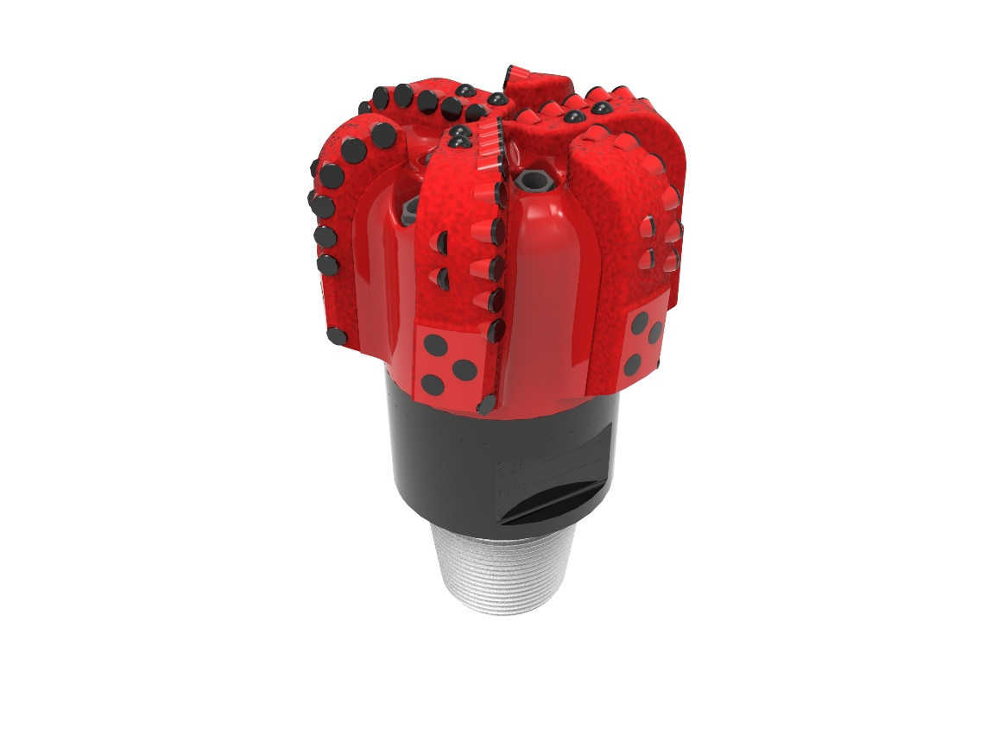
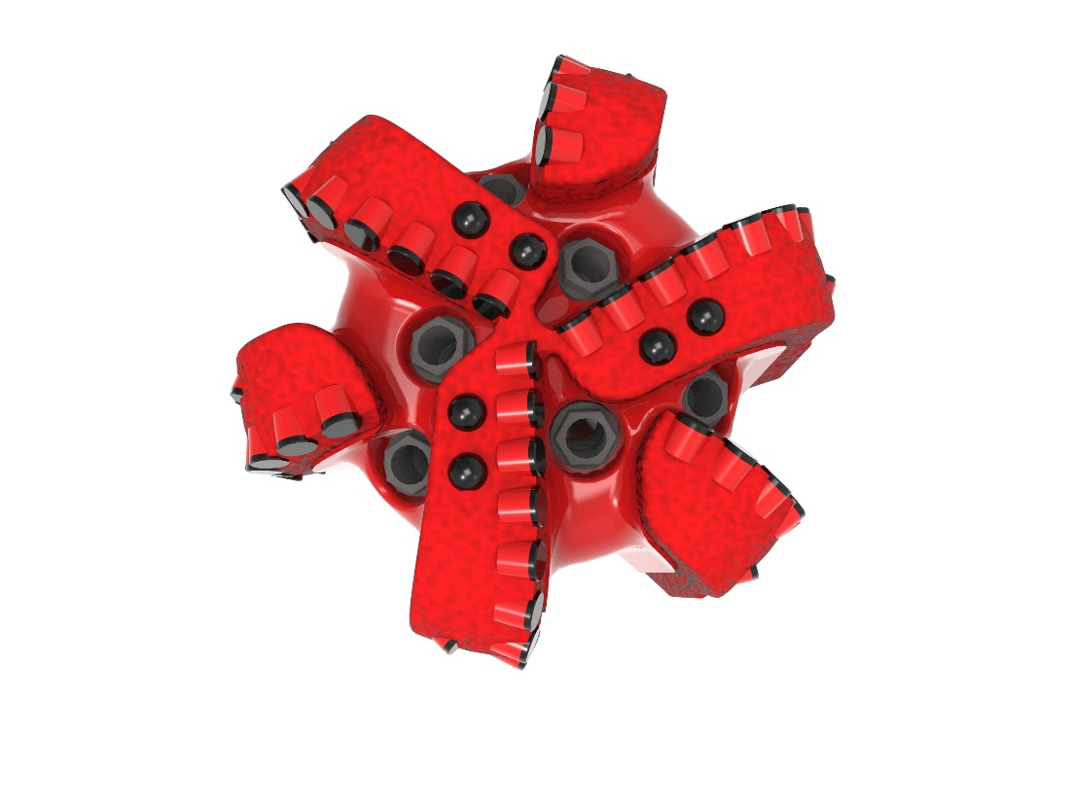

Drill Bit Specifications:
Cutter Size (Primary) | 1/2”
Cutter Count (Total, Gage, Back Reaming) | 64,12,6
Blade Count | 6
Gage Length (Inches) | 2.00
Nozzle Count (Primary, Sec.) | 6
Nozzle Series (Primary, Sec.) | 60
JSA (Sq. Inches) | 16.45
Max. TFA (Sq. Inches) | 2.23
Operating Parameters:
Max. Weight on Bit (1,000 Lbs.) | 60
Make-up Torque (ft/lbs) | 16,488
Nominal Dimensions:
Overall Length (Inches) | 14.2
Make Up Length (Inches) | 10.08
Bit Breaker | SKB-21010
Connection | Ø4-1/2" API Reg.
Approx. Weight (Lbs.) | 100

Standard Features:

- Premium grade cutters maximize ROP and Life
- Nozzle configuration and large open face volume optimize blade cleaning and cuttings removal

613-SR+(K)(BR) Nomenclature Explained:

• | 6 | = | Number of blades
• | 13 | = | Primary Cutter Size (13mm)
• | SR+ | = | Partial Backup Row of Cutters
• | K | = | Bullets
• | BR | = | Back Reamers


